Deriving the Aggregate Demand Curve (AD)
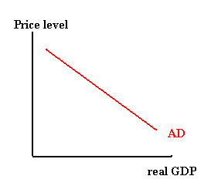
- According to the AD curve, what is the relationship between the price level and real GDP?

- Explain how each of the following effects helps explain why the AD curve is downward sloping.

  - Wealth effect (or real-balance effect) -
  - Interest rate effect -
  - Net export effect -

- In what ways do the reasons that explain the downward slope of the AD curve differ from the reasons that explain the downward slope of the demand curve for a single product?

Shifts to Aggregate Demand

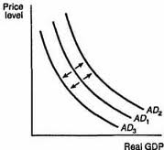

- Using the diagram above, determine whether each situation below will cause an increase, decrease or no change in AD. Always start at curve AD₁. If the situation would cause an increase in AD, draw an up arrow in column 1. If it causes a decrease, draw a down arrow. If there is no change, write NC. For each situation that causes a change in aggregate demand, write the label of the new demand curve (AD₂ or AD₃) in column 2. Move only one curve.

Situation | Change in AD | New AD Curve
A) Congress cuts taxes
B) Stock market collapses; investors lose billions.
C) Government spending to increase next fiscal year; president promises no increase in taxes.
D) Survey shows consumer confidence jumps
E) President cuts defense spending by 20 percent; no increase in domestic spending.

